*\*\*STATE DIAGRAMS ABOUT 25-28 REQUIREMENTS****\*\****

***Object 1: Admin***

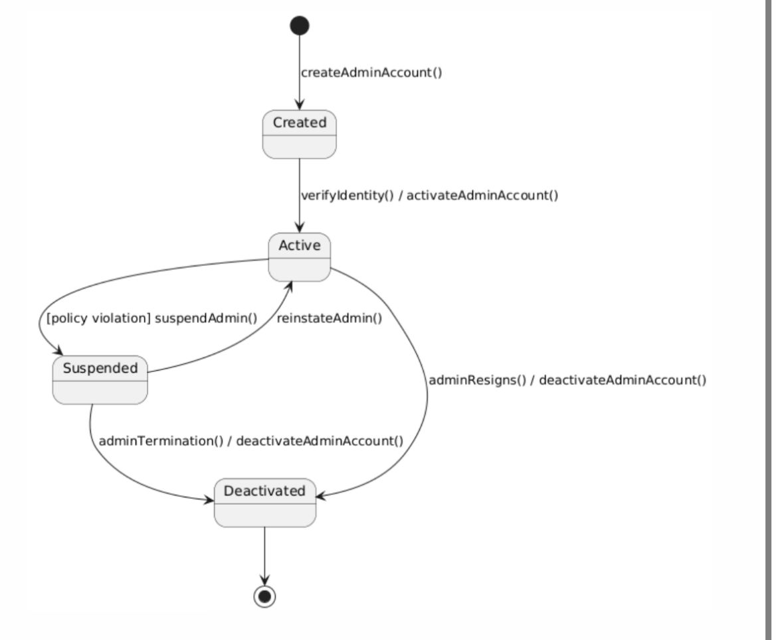

***Object 2: Report***

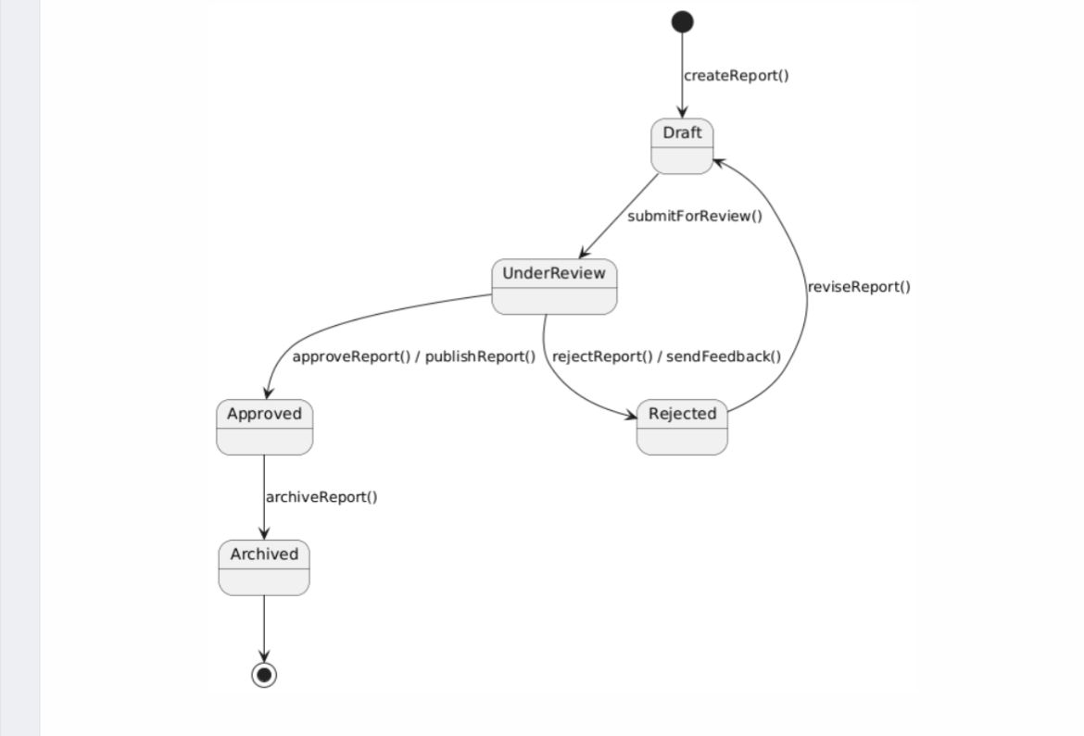

***Object 3: Feedback***

